3GPP TSG-RAN WG4 Meeting #119 R4-2606268
Dalian, CHINA, May 18 - 22, 2026
Agenda Item: 8.10.3
Source: BUPT, China Telecom
Title: Feasibility and performance evaluation for collaborative Multi-TRP sensing
Document for: Approval

Introduction
In the last RAN4 #118bis meeting, the feasibility study for 6G sensing was discussed. While TRP monostatic and TRP-TRP bistatic modes for UAVs were agreed upon, the inclusion of 'Multiple TRP monostatic' remains FFS [1]. To address this FFS and provide concrete technical evidence, this contribution proposes a collaborative Multi-TRP ISAC network architecture and presents feasibility study results based on a prototype verification system. The performance of key indicators demonstrates the necessity of Multi-TRP sensing.

Discussion
  - Collaborative Multi-TRP ISAC Network Architecture
A typical ISAC network architecture is expected to consist of a Radio Access Network (RAN), User Equipment (UE, e.g., UAVs), and a Core Network (CN) equipped with a sensing server and one or more sensing clients. The sensing client initiates requests regarding the target's information, such as size, position, and velocity. Based on the specific request, the network configures and triggers the corresponding sensing process, which includes radio resource scheduling, sensing data processing, and reporting the results back to the client.
Fig. 1 Framework for multiple stations enabled sensing
To support this, a three-layer framework for a base station-based ISAC architecture is utilized:
- Sensing Client: Dispatches various sensing service requests (e.g., UAV trajectory tracking, environmental monitoring, intrusion detection) to the sensing centers. These requests include performance requirements (distance/speed/angle accuracy and resolution) and result feedback requirements (e.g., reporting cycle).
- Multi-station Collaborative Sensing Center in CN: Tightly coupled with the core network, this center receives sensing requests via specific interfaces. Upon authorization, it generates sensing configuration parameters and result reporting requirements. The configuration parameters include the target's positioning requirements and basic access network parameters related to sensing capabilities.
- Edge Sensing Center in RAN: Acting as the data plane sink for the multi-station collaborative sensing center, it offloads sensing services and handles data tasks alongside lightweight control functions. Its functionalities include interacting with the core sensing center for authorization and result reporting, collecting raw sensing data from covered TRPs to dynamically configure sensing functions, and interacting with neighboring (uncovered) TRPs to rapidly activate their sensing capabilities.

Observation 1: Collaborative Multi-TRP sensing can be realized by introducing a Sensing Function (SF) in the Core Network or an Edge Sensing Function (ESF) in the RAN.
  - Performance Evaluation of Collaborative Sensing
A hardware prototype verification system was built, comprising a multi-station collaborative sensing center and two 5G millimeter-wave communication platforms. The prototype targets a moving object (e.g., representing a UAV), which aligns with the agreed sensing targets. Each platform includes two 64-element Phased Array Antennas (PAA) configured for ISAC signal transmission and sensing signal reception, alongside a horn antenna for communication signal reception. This allows the platform to receive sensing and communication signals simultaneously.
Fig. 2 Prototype of the multi-station collaborative ISAC platform
Testing was conducted on a target moving in a circular trajectory across 16 different positions. The results demonstrate that two collaborative ISAC systems, utilizing a specific data fusion algorithm, achieve significant gains in both distance and speed estimation compared to a single ISAC system. Notably, the Root Mean Square Error (RMSE) for ranging improved by more than 50% at certain positions. Concurrently, the system successfully maintained a continuous peak communication data throughput of 2.8 Gbps.
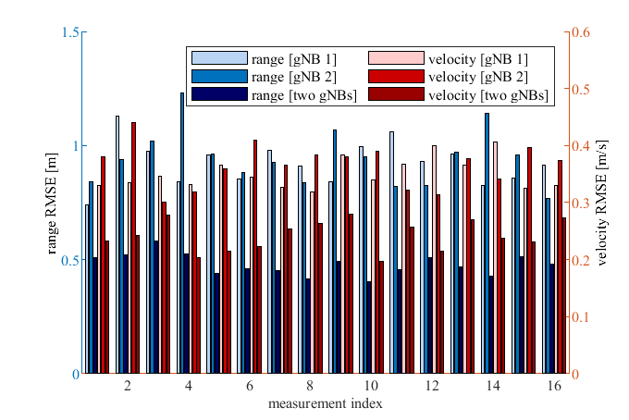
Fig. 3 Ranging and velocity RMSE of dual-station single-target detection

Proposal 1: Based on the significant performance gains observed in both ranging and velocity RMSE, RAN4 should confirm the study of Multiple TRP monostatic (resolving the FFS from #118bis) to advance beyond the 5G-A focus on single base station sensing.

Conclusions
Based on the architectural analysis and performance evaluations, we propose the following for the 6G ISAC study item:
Observation 1: Collaborative Multi-TRP sensing can be realized by introducing a Sensing Function (SF) in the Core Network or an Edge Sensing Function (ESF) in the RAN.
Proposal 1: Based on the significant performance gains observed in both ranging and velocity RMSE, RAN4 should confirm the study of Multiple TRP monostatic (resolving the FFS from #118bis) to advance beyond the 5G-A focus on single base station sensing.

References
[1] R4-2605009, Way Forward for [118bis][362] 6G_Sensing, ZTE

